**OOP Quiz 2**

The following diagram demonstrates some relationships between different classes.

1. Write Java code according to the following diagram that shows the relationship between a robot, it’s head, wheels and hands.

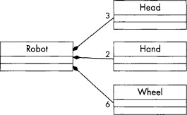

1. Write a code that demonstrates the following hierarchy of different types of robots. Demonstrate how each class overrides the perform() functions for its parent class. Each class must also call the parent class’s perform() function.

